**Evaluating the Influence of Aspect on Slope Gradient in the Poudre Valley**

## **Abstract**

This study investigates whether slope aspect influences slope gradient along a 16-kilometer east-west segment of the Poudre River in northern Colorado. The hypothesis tested was that south-facing slopes would be steeper than adjacent north-facing slopes due to greater solar radiation and reduced vegetation cover. Ten slope pairs were selected and measured using Google Earth Pro elevation profiles. Average slope gradients were calculated and compared using a two-sample t-test. The analysis revealed no statistically significant difference in slope steepness between aspects (p = 0.96). Field observations at five sites supported microclimatic vegetation differences but showed consistent lithology and moderate jointing across slopes. These findings suggest that in this region, aspect does not strongly influence slope gradient, and that local lithology and geomorphic history may play more dominant roles.

## **Introduction**

Slope aspect is widely recognized as a significant control on microclimate and surface processes in mountainous regions. In the northern hemisphere, south-facing slopes typically receive more direct solar radiation, resulting in warmer and drier conditions than those found on north-facing slopes. These microclimatic differences can influence a variety of geomorphic factors, including vegetation density, soil development, and weathering intensity. In theory, such variations should produce observable differences in slope morphology over time, with south-facing slopes expected to be steeper due to enhanced surface erosion and reduced vegetative stabilization.

Despite this common expectation, recent studies suggest that the relationship between aspect and slope gradient is not always straightforward. Local geological factors such as lithology, rock structure, and jointing, as well as biological influences like root systems and ground cover, can mediate or override the effects of aspect. In areas with complex terrain or mixed lithologies, slope form may be shaped more by underlying geologic controls or episodic mass-wasting events than by long-term differences in microclimate.

This study tests the hypothesis that south-facing slopes along the Poudre River are steeper than adjacent north-facing slopes. In the northern hemisphere, increased solar exposure on south-facing slopes typically leads to higher rates of surface drying, reduced vegetation cover, and more intense physical weathering processes such as freeze-thaw cycling. These conditions are thought to promote more frequent erosion and reduced slope stability, which over time may result in steeper average gradients compared to cooler, more vegetated north-facing slopes. Previous studies have shown that aspect can exert strong controls on cliff retreat and bedrock weathering, particularly in arid regions where thermal stress dominates (Shmilovitz et al., 2023).

In more temperate mountain systems, slope stability has been linked to vegetation density, which is itself influenced by aspect and associated microclimate conditions (McGuire et al., 2016). To evaluate whether aspect influences slope morphology in this region, slope gradients were measured on ten north-facing and ten south-facing slopes using elevation profiles generated in Google Earth Pro. The average slope gradient for each aspect was calculated, and the difference in average slope gradients between aspects was assessed for statistical significance using a two-sample t-test assuming unequal variances.

## **Study Area, Methods, and Field Observations**

The study was conducted along a 16-kilometer segment of the Poudre River in northern Colorado, located within the eastern foothills of the Rocky Mountains. The Poudre River flows predominantly eastward through the Colorado Front Range, offering numerous opportunities to examine paired north- and south-facing slopes on opposite sides of the valley. This orientation makes the valley particularly suitable for investigating the geomorphic effects of slope aspect, as opposing slopes experience substantially different solar exposure regimes.

The local terrain features rugged foothills, ridgelines, and steep valley walls shaped by both tectonic uplift and prolonged fluvial incision. Bedrock in the study area is primarily composed of gneiss and granite, which tend to form steep, resistant slopes with limited soil development. In several areas, thin bands of sedimentary rocks such as sandstone and shale are exposed at lower elevations, contributing to localized variability in slope morphology. Observations at five representative sites indicated moderate to high degrees of jointing, particularly in granite outcrops, with visible vertical and horizontal fractures that likely influence slope stability and weathering processes.

Vegetation cover in the region reflects microclimatic differences between aspects. North-facing slopes were generally more densely vegetated, with continuous ground cover consisting of grasses, shrubs, and scattered trees. In contrast, south-facing slopes exhibited patchier vegetation, with more exposed bedrock and areas of bare soil, particularly on mid-to-upper slope positions. This pattern is consistent with reduced moisture retention on south-facing slopes due to increased solar exposure. Surface observations also suggested that vegetative root systems may contribute to minor slope reinforcement, particularly on north-facing slopes where cover was more extensive.

Ten slope pairs were selected at intervals along the river, spaced to ensure geographic diversity while maintaining similar elevation and topographic relief. Each pair included one north-facing and one south-facing slope, selected for clear aspect contrast and relatively uniform local geology. Slope gradients were measured using elevation profiles generated in Google Earth Pro. For each slope, a transect was drawn perpendicular to the river valley from base to crest, and the average slope percentage provided by the software was recorded. Only average slope values were used in order to capture general slope form while minimizing the influence of localized topographic irregularities.

The resulting dataset comprised ten slope measurements for each aspect group. Descriptive statistics were calculated for both sets, and a two-sample t-test assuming unequal variances (Welch’s t-test) was performed in Microsoft Excel to determine whether the observed differences in mean slope gradient were statistically significant. A significance threshold of α = 0.05 was applied to test the null hypothesis.

The spatial distribution of the sample sites is illustrated in Figure 1 (p. 8), which provides a satellite view of the study corridor and highlights the general layout of slope pairs along the river’s course.

## **Results**

Slope gradient measurements from ten north-facing and ten south-facing slopes yielded a narrow range of average values. South-facing slopes had a mean gradient of M = 35.3%, while north-facing slopes had a mean of M = 35.1%. Standard deviations were 10.6% and 6.0%, respectively, indicating slightly greater variability among south-facing slopes. The following table summarizes each slope aspect's average slope gradient, elevation gain, and horizontal distance.

| **Aspect** | **Mean Elevation Gain (m)** | **Mean Horizontal Distance (m)** | **Mean Slope (%)** | **Standard Deviation** |
| --- | --- | --- | --- | --- |
| South | 92.1 | 258.0 | 35.3 | 10.6 |
| North | 119.6 | 323.1 | 35.1 | 6.0. |

A two-sample t-test assuming unequal variances revealed no statistically significant difference in mean slope gradients (p = 0.96). The box-and-whisker plot below displays the distribution of slope values by aspect. Both slope groups exhibit similar medians and interquartile ranges, with some variability at the upper extremes, particularly among south-facing slopes.

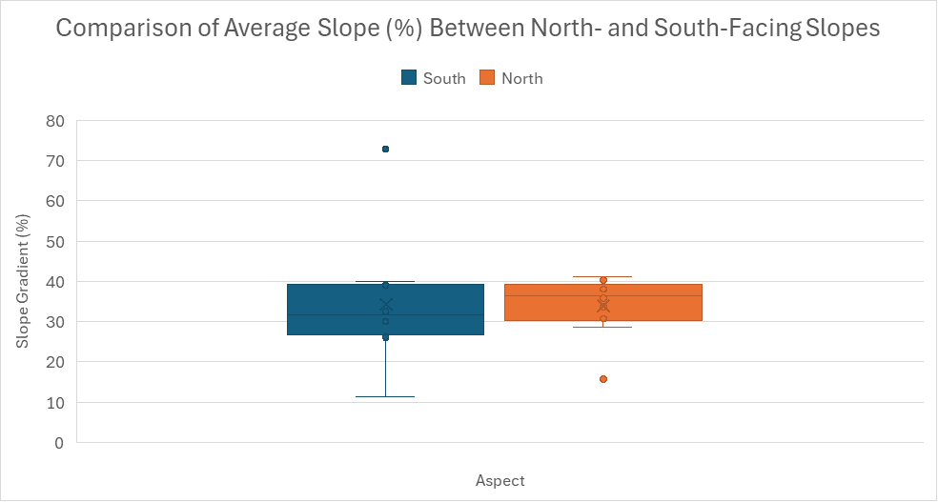**Discussion**

The results of this study indicate no significant difference in slope gradient between aspects, contradicting the hypothesis that south-facing slopes in the Poudre River Valley are steeper than adjacent north-facing slopes. Although aspect is widely cited as a control on slope morphology—through its influence on insolation, soil moisture, and vegetation cover—the findings suggest that other geomorphic factors may be more influential in determining slope gradient at the local scale.

One likely explanation is the dominant role of bedrock type and structure in controlling slope form. Field observations indicated that both slope aspects were underlain primarily by resistant igneous and metamorphic rocks, such as granite and gneiss. These lithologies tend to produce steep, stable slopes regardless of solar exposure, especially when jointing is moderate and blocky. While south-facing slopes exhibited slightly more bare rock and less continuous vegetation, this contrast may not have been sufficient to generate meaningful differences in long-term erosional processes or slope evolution.

Vegetation cover did differ between aspects, with north-facing slopes supporting denser and more continuous plant growth. However, this pattern may exert more influence on surface processes such as soil retention and shallow slope stability than on the overall gradient of bedrock-dominated slopes. McGuire et al. (2016) found that during an extreme rainfall event in the Colorado Front Range, most shallow landslides occurred on sparsely vegetated south-facing slopes, highlighting the stabilizing role of vegetation, particularly root reinforcement, on slope integrity. Although landslides were not the focus of this study, these findings suggest that aspect may influence slope behavior more through vegetation-driven stability than through long-term differences in gradient.

This conclusion is further supported by Shmilovitz et al. (2023), who found that in the hyperarid Negev Desert, south-facing cliffs exhibited greater weathering and retreat, leading to lower slope angles than those on north-facing slopes. Their study demonstrates that greater solar exposure does not always result in steeper slopes and that aspect can sometimes accelerate breakdown and flattening of bedrock surfaces. Taken together, these studies suggest that the geomorphic influence of aspect is context-dependent and shaped by interacting climatic, lithologic, and biologic processes.

Finally, methodological limitations should be considered. Google Earth Pro, while a useful tool for measuring slope profiles, has limited resolution and precision compared to field-based topographic surveys or high-resolution LiDAR data. The sample size of ten slope pairs, while sufficient for basic statistical testing, may also be too small to detect subtle patterns, particularly in a geologically complex landscape.

These findings emphasize the need to consider multiple geomorphic controls when evaluating slope morphology. While aspect can influence surface conditions and microclimate, its effect on slope gradient may be minimal in areas where lithologic and structural factors dominate.

## **Conclusion**

This study tested the hypothesis that south-facing slopes would exhibit steeper gradients than north-facing slopes in the Poudre River Valley, based on expected differences in solar radiation, vegetation cover, and surface moisture. Using slope measurements derived from Google Earth Pro and limited field observations, the analysis revealed no statistically significant difference in mean slope gradient between aspects.

These results suggest that in this region, slope aspect alone does not exert a dominant influence on overall slope morphology. Instead, factors such as bedrock type, joint density, and geomorphic history likely play a more substantial role in shaping slope profiles. While aspect-related differences in vegetation and surface exposure were observed, they did not translate into measurable differences in average slope steepness. Future studies could expand on this work by incorporating higher-resolution elevation data or exploring how aspect influences other slope properties such as soil development or surface stability.

**References**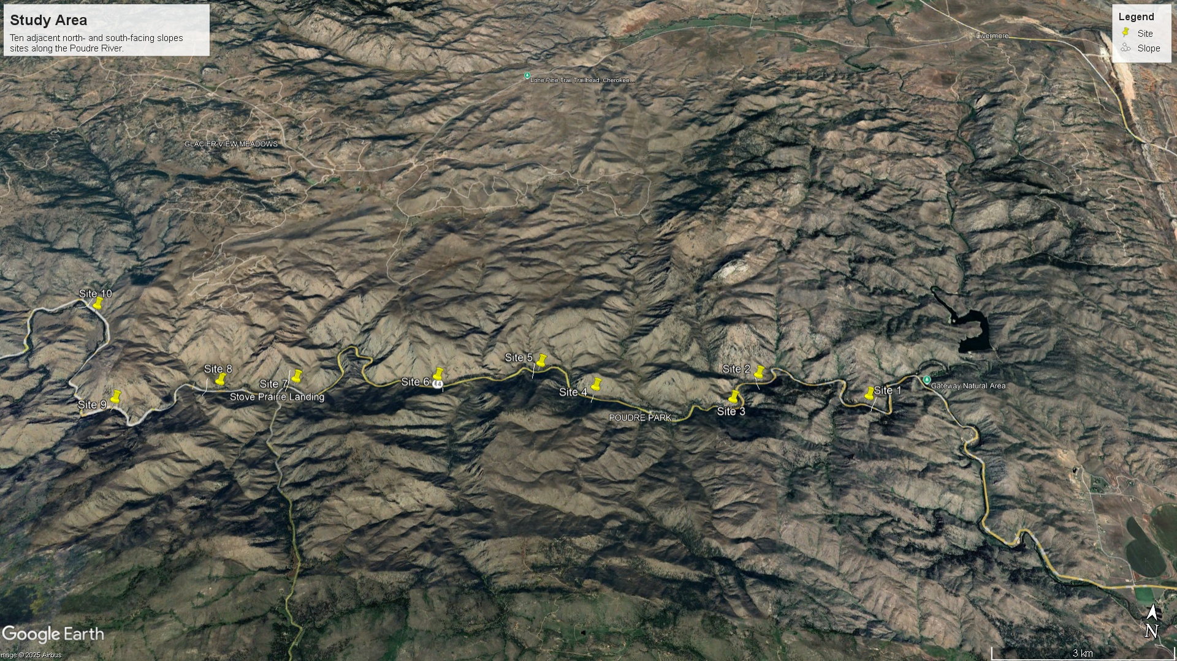

Fig. 1. Map of the study area along a 16 km segment of the Poudre River in northern Colorado, showing locations of the ten slope pairs sampled. Each site includes one north-facing and one south-facing slope situated on opposite sides of the river valley. Base imagery from Google Earth Pro.

McGuire, L.A., Kean, J.W., Staley, D.M., Rengers, F.K., and Hobley, D.E., 2016, Elucidating the role of vegetation in the initiation of rainfall-induced shallow landslides: Insights from an extreme rainfall event in the Colorado Front Range: Geophysical Research Letters, v. 43, pp. 9084–9092.

Shmilovitz, Y., Siman-Tov, S., Avni, Y., and Porat, N., 2023, Aspect-dependent bedrock weathering, cliff retreat, and cliff morphology in a hyperarid environment: GSA Bulletin, v. 135, pp. 1955–1966.

**Appendix**

| **Site** | **Aspect** | **Elevation Gain (m)** | **Horizontal Distance (m)** | **Slope (%)** |
| --- | --- | --- | --- | --- |
| 1 | South | 91.7 | 246 | 30.8 |
| 1 | North | 127 | 305 | 38 |
| 2 | South | 79.3 | 242 | 26.9 |
| 2 | North | 136 | 369 | 36.9 |
| 3 | South | 74.5 | 172 | 72.9 |
| 3 | North | 105 | 277 | 33.7 |
| 4 | South | 101 | 265 | 32.5 |
| 4 | North | 77.7 | 262 | 28.6 |
| 5 | South | 38 | 199 | 11.4 |
| 5 | North | 160 | 397 | 41.2 |
| 6 | South | 87.5 | 288 | 30.1 |
| 6 | North | 184 | 428 | 40.3 |
| 7 | South | 144 | 327 | 39.9 |
| 7 | North | 90 | 285 | 30.7 |
| 8 | South | 74.4 | 261 | 26.1 |
| 8 | North | 142 | 323 | 38.9 |
| 9 | South | 139 | 313 | 39 |
| 9 | North | 47.2 | 123 | 15.7 |
| 10 | South | 99 | 257 | 32.9 |
| 10 | North | 114 | 202 | 35.8 |

Table 1. A full representation of the horizontal distance, elevation gain, and slope for slopes of different aspects in the Poudre Valley. Data taken from Google Earth Pro.